Office No. J-1031, Akshar Business Park, Plot No. 03 Sector 25, Near APMC Market, Vashi, Navi Mumbai, Maharashtra 400703 TEL: 022-46090378/79/80 Email: vsjcvaluer@gmail.com.
Web site: www.vsjadon.com

VALUATION REPORT

Name of Branch : ONGC Date: 16/08/2024.

Name of Customer (s)/ Borrower Unit- Nitesh Manohar Thaware.

1 | Customer Details
1 | Owner/Seller Name |  |  | Mr. Babaso Jagannath Mahadik & Mrs. Lakshmi Babaso Mahadik.
1 | Apl No. |  |  | NA
2 | Property Details
2 | Address |  |  | Flat No. 504, 5th Floor, A Wing, Malhar Residency, Plot No. 45A, Sector No. 10, Village. Kamothe, Navi Mumbai, Tal. Panvel, Dist. Raigad - 410209.
2 | Nearby Landmark/ Google Map Independent access to  the property |  |  | Near Croma - Kamothe & Manthan Residency.
 | Longitude |  |  | 19.0187000 |  |  |  |  | Latitude |  | 73.0955500
3 | Document Details |  |  |  | Name of Approving Authority
3 | OC |  |  | Yes | PMC |  |  |  | Approval No |  | No. 2018/PMC/BP/2671/2018, Dated: 07/03/2018. (Approved Plan Gr + 6th Floor).
3 | Copy Of Approved Plan |  |  | Yes | CIDCO |  |  |  | Approval No |  | CIDCO/ATPO/(BP)ATPO/1510, Dated: 03/12/2012. (Approved Plan Gr + 6th Floor).
3 | Legal Documents |  |  | Yes | 1. Copy of Sale Agreement & Index II: 14468/2017, Dated: 18/12/2017.
 | Physical Details
 | Adjoining Property |  | East | NA |  | West | NA | North |  | NA |  | South | NA
 | As per  documents |  | East | NA |  | West | NA | North |  | NA |  | South | NA
 | Matching of Boundaries |  |  | No |  | Plot Demarcated | Yes | Approved Land Use(Indus trial/Commercial /Residential) |  | Residential |  | Type of Property | 1 BHK Residential Flat (As per Approved Plan)
 | No of room | 1 BHK Flat.

 | Total No of Floor |  | Gr + 6th Floor with 01 Lift. | Floor on which the property is located On 5th Floor (habitable) |  | Age of the Property |  |  | 07 Year ( As per OC) |  | Residual Age of the Property |  |  |  | 53 year (After Construction) |  | Type of structural – RCC  framed/stone /BB/maso nry |  | RCC Framed Structure
5 | Tenure/Occupancy Details
5 | Status of Tenure |  |  | Tenant |  |  | No of years of Occupancy: - |  |  |  |  |  |  | Relationship of tenant or owner |  |  |  |  | -
6 | Stage of Construction: Completed.
6 | Stage of Construction: 100% |  |  | 100% |  |  |  |  |  |  |  |  | If under construction, extent of completion:  100 %
7 | Violations if any observed
7 | Nature and extent of Violations |  |  |  |  |  |  | NA
8 | Area Details of the property
8 | carpet Area | 269.00 Sq. Ft. (As per Index II & Sale Agreement) |  |  | Sealable Area |  | 390 Sq.ft (Derived from 45% Loading on CA @ Index II & Sale Agreement) |  |  | carpet Area |  | 297.00 Sq. Ft. (As per Approved Plan) |  |  |  | Sealable Area |  | 431 Sq.ft (Derived from 45% Loading on CA @ Index II & Sale Agreement)
 | Gross Carpet Area | 367.00 Sq. Ft. (As per measurement) |  |  | Sealable Area |  | 532.00 Sq. Ft. (Derived from 45% Loading on CA @ As per measurement)
9 | Valuation
9 | - Mention the as per Government Approved Rate also: - 7590.115 Sq.ft on BUA on IGR.  - In Case of valuation of 20% or more in the valuation proposed by the value and the guideline value provide in the  - State Govt. Notification or income Tax Gazette justification on variation has to be given  Summary of valuation:

- Saleable Area : 532 Sq.ft.
Market Rate : 10200 Per Sq. Ft. Saleable Area
- Market Value : 54,26,400/-
- Expected Rental Value : 11,000 Per Month.
- Fair Market Value : 54,26,400 Fifty Four Lakh Twenty Six Thousand Four Hundred

- Realizable Value : 48,83,760 Forty Eight Lakh Eighty Three Thousand Seven Hundred Sixty

- Force / Distress Sale Value : 46,12,440 Forty Six Lakh Twelve Thousand Four Hundred Forty
vii. Insurable Value : Built Up Area * Cost of Construction
441 2500
11,01,480/-
10 | Assumptions/Remarks |  | Remark:-  1. We have released report on the basis of the provided documents i.e. Copy of Sale Agreement, Index II, OC & Approved Plan.  2. Property identified by Mr. Nitish ( Mob. 7798071129).  3. Property inspected by Mr. Sunil Peravi. (Engineer).  4. Interior & exterior of the Property is Good.  5. We have considered age of the property as per OC.  6. Market phenomenon regarding market value has been changing. In recent times properties are sold for a lump sum price (All Charges Parking), because of the statutory restriction on built up or carpet area in documents .So the market rate is derivatives of market value And area in document. Market rate given in report is not comparable to open enquiry in market.  7. We have considered measurement area for valuation, i.e. 45% loading on CA.
11 | Declaration |  | - The property was inspected by the undersigned on: 04/08/2025.  - The undersigned does not have any direct/indirect interest in the above property  - The information furnished here in is true and correct to the best of our knowledge.  - We have submitted Valuation report directly to the bank.
12 | Name address & signature of valuer with Wealth Tax Registration No. |  | Signature of Valuer | Date of Valuation: 16/08/2025.
13 | Enclosures Documents &  Photographs (Geo |  | Enclosed

Photographs of Property of: Mrs. Manisha Meena & Mr. Shankar Lal Meena

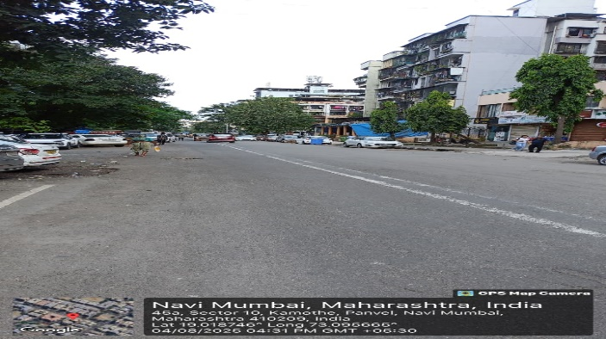
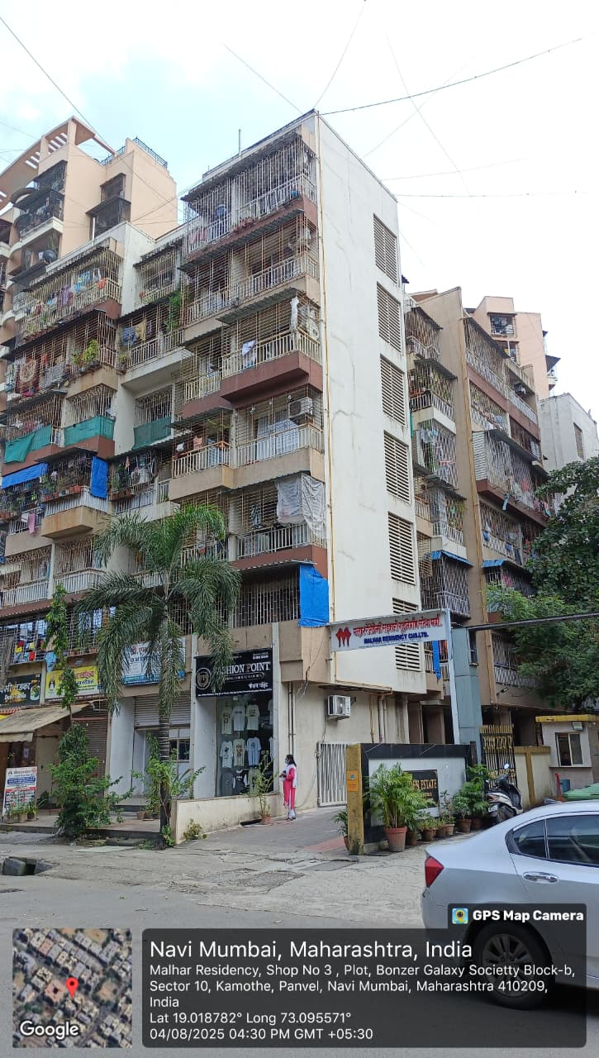
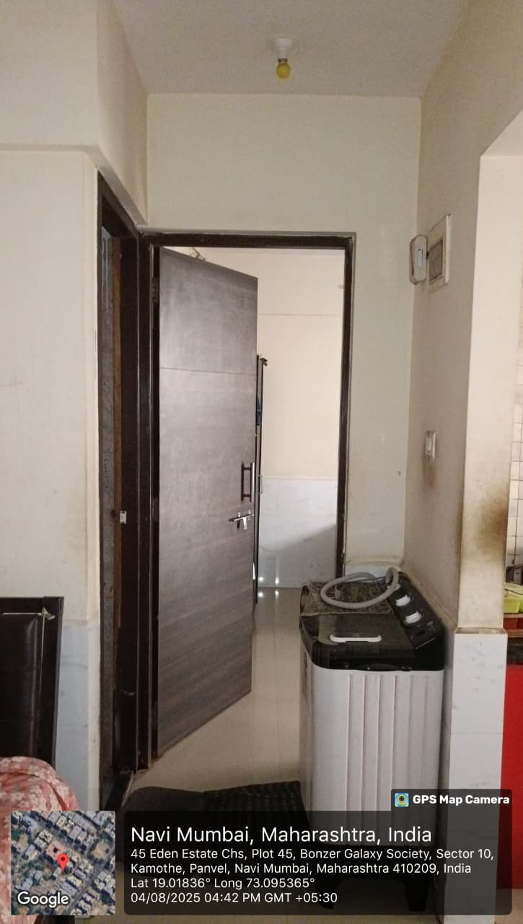
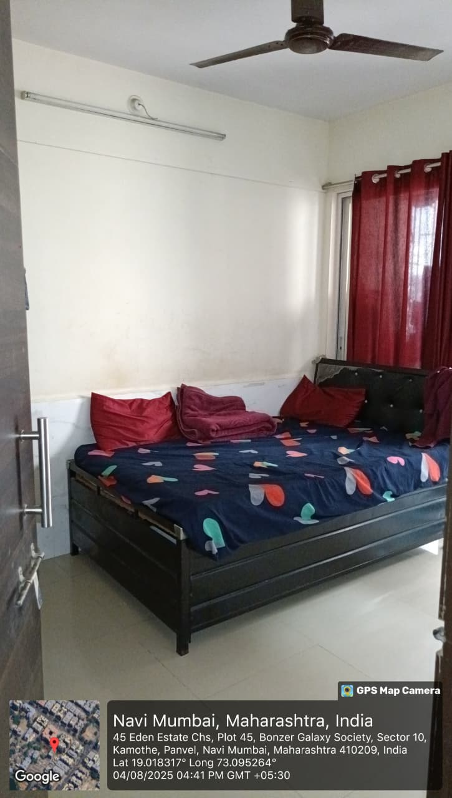
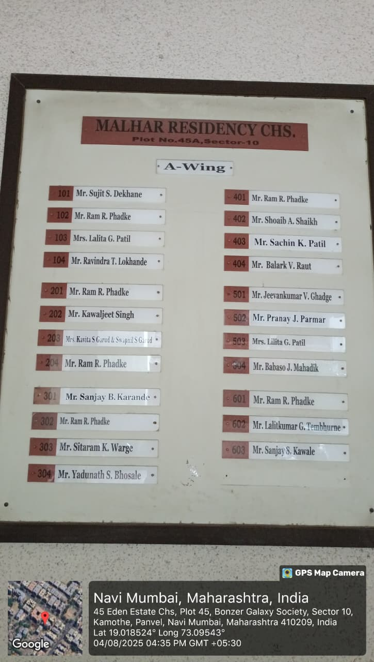
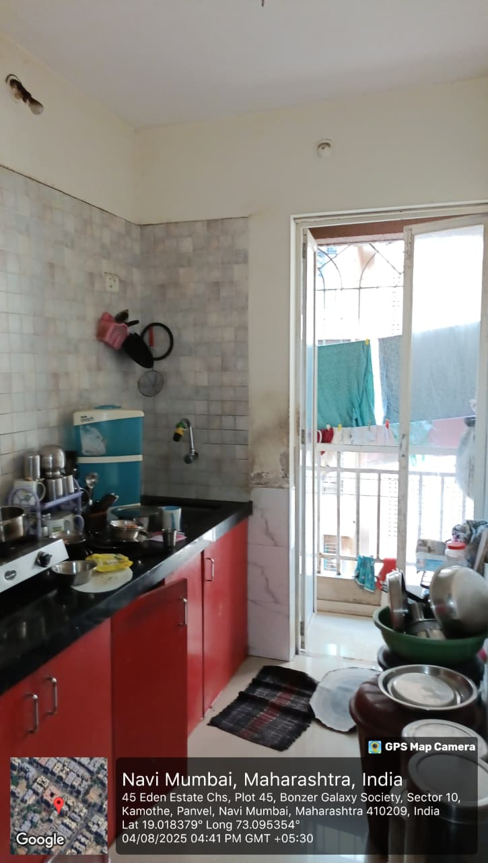
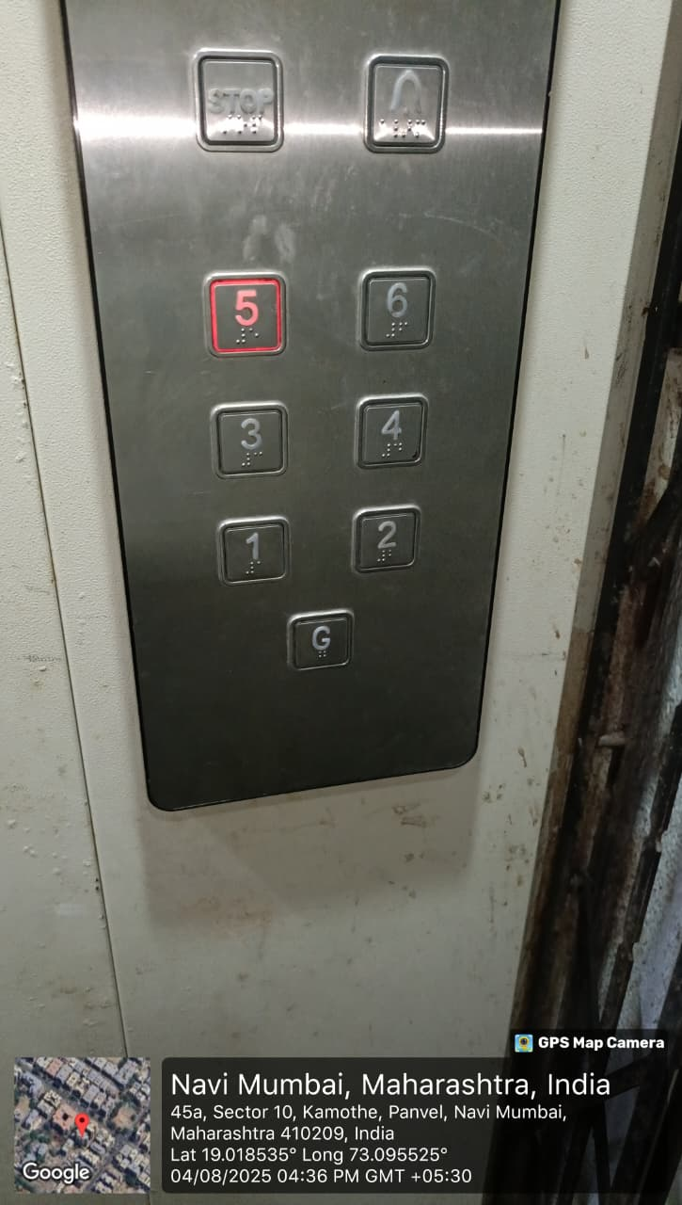
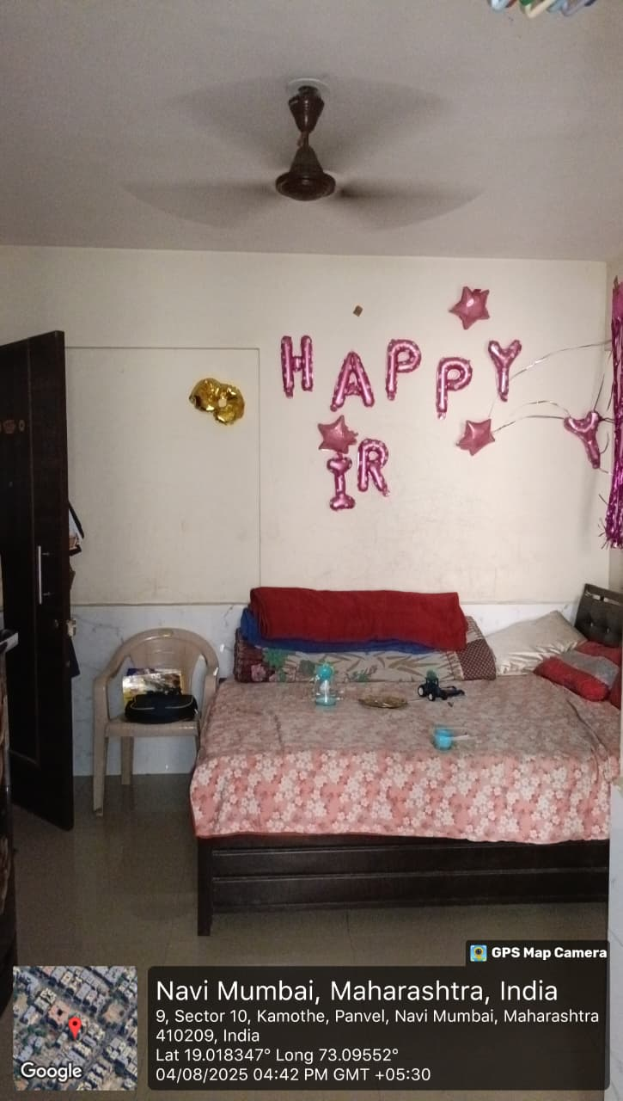

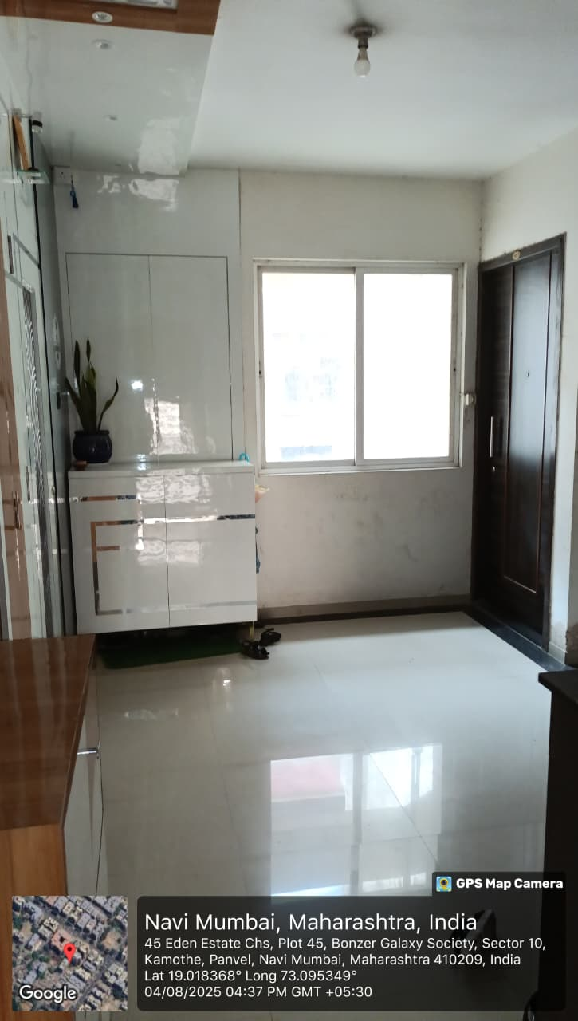
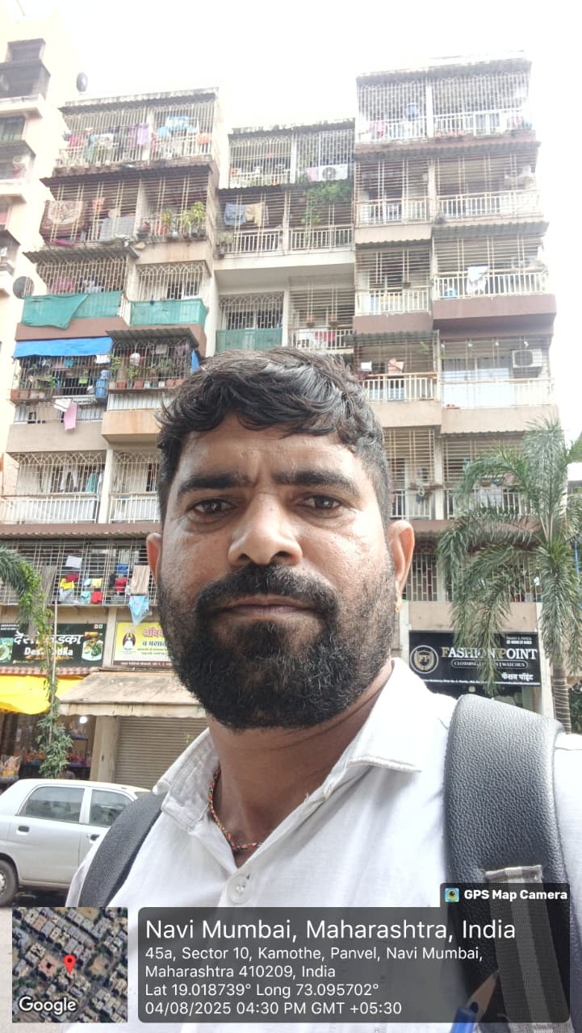
Google Map:

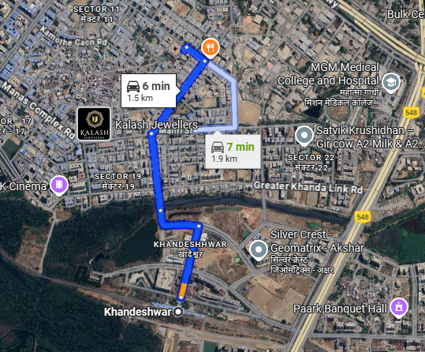

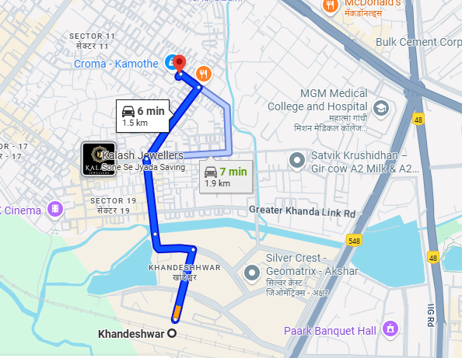

Documents

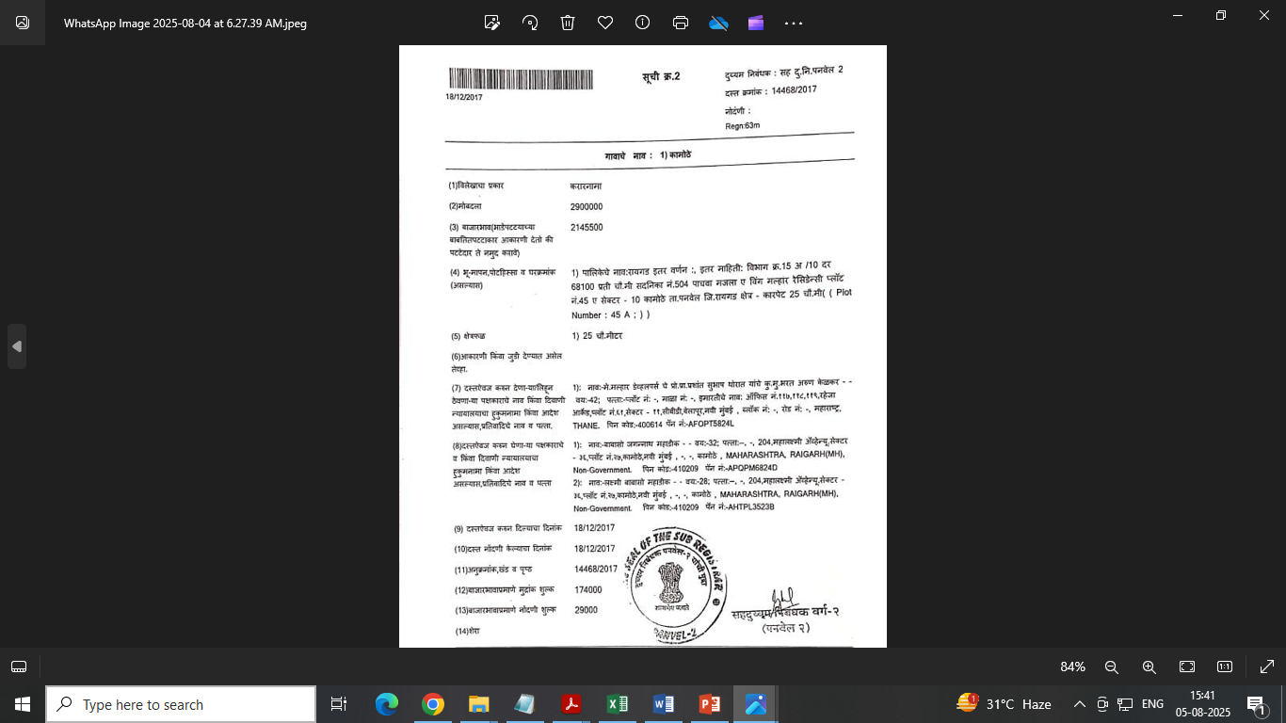

Government Rate

