\
VALUATION OF IMMOVABLE PROPERTY OWNED BY

Mr. Amit Anand Patki

SITUATED AT

Flat No. A-46, 2nd Floor, Building A, Niranjan CHSL, Survey No. 121/1, Near Ratan Krupa Apartments, Pashan Sus Road, Village. Sutar Wadi, Pashan, Dist. Pune-411021.

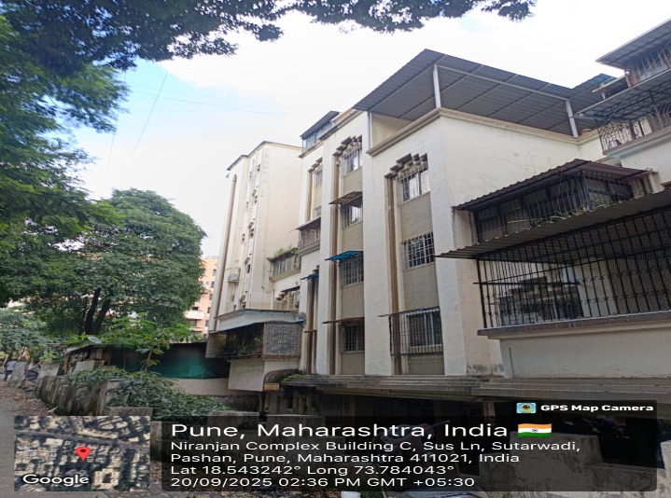

ASSIGNMENT FOR

BANK OF MAHARASHTRA
PRABHADEVI BRANCH, MUMBAI

DATE OF INSPECTION DATE OF REPORT 20-09-2025. 23-09-2025
Report No.: VSJCVNM-BOM-RTL-SEP25-22220 DATE: 23-09-2025.

To,
The Manager
“Bank of Maharashtra”
Prabhadevi Branch, Mumbai.

VALUATION REPORT: RESIDENTIAL FLAT

PART A

I. | GENERAL
1. | Purpose of Valuation | : | To Assess Fair Market Value for Loan  Syndication Purpose
2. | a. Date of Inspection | : | 20/09/2025.
 | b. Date on which the valuation is made | : | 23/09/2025.
3. | Name of the owner(s) (details of  share of each owner in case of joint ownership) | : | Mr. Amit Anand Patki
 | Name of the prospective Purchasers | : | Balu Sutar
4. | Documents Produced for Perusal | :
- Sale Agreement made between M/S Niranjan Promoters & Devlopers prv. LTD (The Seller / Transferor / Promotor) and Mr. Amoit Anand Patki & Other (The Purchaser / Transferee / Allottee) (The Purchaser / Transferee / Allottee).Verified Dated: 20/02/1997.
- OC– BC0/6/OC/785, Dated 09/03/2000
5. | Brief Description of the Property | : | 2 BHK Flat.
 | The property under report is a Residential Unit Situated at. Flat No. A-46, 2Nd Floor, Building A, Niranjan Chsl, Survey No. 121/1, Pashan Sus Road, Village, Sutar Wadi, Pashan, Dist. Pune 411021, The Residential building is located about 1.6 km. distance from Pashan Sus Road, Bus Stop
6. | Location of the property | : | Village, Sutar Wadi, Pashan
 | Gat No. |  | Survey No. 121/1
 | Name of Nagar/Layout |  | -
 | S. F. No/T. S. No./R. S. No. |  | Survey No. 121/1
 | Village / Block |  | Village, Sutar Wadi, Pashan
 | Taluka / Ward |  | Haveli
 | Mandal/District/Municipality/  Corporation |  | Corporation
7. | Postal Address of the Property with Pin Code |  | Flat No. A-46, 2Nd Floor, Building A, Niranjan Chsl, Survey No. 121/1, Pashan Sus Road, Village, Sutar Wadi, Pashan, Dist. Pune - 411021

8. | City / Town |  |  | : | Pashan
 | Residential Area |  |  | : | Yes
 | Commercial Area |  |  | : | ---
 | Industrial Area |  |  | : | ---
9. | Classification of locality |  |  | : | - Prime Residential Locality  - Urban
10. | Coming under Corporation Limit /  Village Panchayat / Municipality |  |  | : | Corporation Limit
11. | Whether covered under any State  /Central Govt. Enactments (e.g. Urban Land Ceiling Act) or Notified under  agency area / scheduled area / cantonment area |  |  | : | No
12. | Boundaries of the property |  |  | :
 |  |  | a. As per the deed |  |  | b. Actuals
 | North | : | By Sus Road |  |  | Road
 | South | : | Sub Plot No 4 &5 |  |  | A4 Wing
 | East | : | Remaining Portion Survey No 121/1 |  |  | A5 Wing
 | West | : | Sub Plot No 4 |  |  | Road
13. | Dimensions of the site |  |  | : | Built-Up Area =610.00 Sq.Ft. + Terrace Area = 48 sq ft = 658.00 sq ft (As per Site)
14. | Extent of the site |  |  | :
14.1 | Latitude, Longitude and Coordinates of  the site |  |  | : | 18.543182362953544, 73.78439406328738
15 | Extent of the site considered for  valuation (least of 13 & 14) |  |  | : | Built-Up Area = 583.00 Sq.Ft Terrace Area = 40 sq ft = 623.00 sq ft (As Per Agreement)
16. | Whether Occupied by the owner/tenant? If Occupied by the  Tenant, Since how long? Rent Received Per Month. |  |  | : | Rented
II. | BUILDING:
1. | Nature of Building |  |  | : | Residential
2. | Unit No. And Floor |  |  | : | Flat No. A-46, 2nd Floor
3. | Name of the Building |  |  | : | Building A, Niranjan Complex
4. | Postal Address |  |  | : | Flat No. A-46, 2nd Floor, Building A, Niranjan Chsl, Survey No. 121/1, Pashan Sus Road, Village, Sutar Wadi, Pashan, Dist. Pune - 411021
5. | Location |  |  | : | Village, Sutar Wadi, Pashan
 | T. S. No. |  |  | : | ---
 | Block No. |  |  | : | ---
 | Ward No. |  |  | : | ---

 | Village / Municipality / Corporation | : | Corporation
 | Door No., Street or Road (Pin Code) | : | Flat No. A-46, Pashan Sus Road
6. | Description of Locality | : | Residential
7. | Year of Constriction (As per OC) | : | 2000
8. | Number of Floors | : | G + 6th Floor with 01 lifts.
9. | Type of Structure | : | R.C.C. Structure
10. | Number of Units in the Building | : | -
11. | Quality of construction | : | Good
12. | Appearance of Building | : | Good
13. | Maintenance/Condition of the Building | : | Exterior: | Good
13. | Maintenance/Condition of the Building | : | Interior: | Good
14. | Facilities Available
 | Lift | : | Yes
 | Protected Water Supply | : | Yes
 | Underground Sewerage | : | Yes
 | Car Parking | : | Yes
 | Open / Covered | : | Covered
 | All-round Compound Wall | : | Yes
 | Pavement Around the Building | : | Yes
 | Any Other Facility | : | CCTV & security
III. | RESIDENTIAL FLAT / COMMERCIAL SHOP / OFFICE
1. | The Floor in Which the Unit is located | : | 2nd Floor
2. | Door Number of the Unit | : | A-46
3. | Specification of The Unit | : | 2 BHK Flat
 | Roof | : | RCC
 | Flooring | : | Tiles
 | Doors | : | Wooden
 | Windows | : | Sliding
 | Fittings | : | concealed
 | Finishing | : | Good
4. | House Tax | : | ---
 | Assessment No. | : | ---
 | Tax Amount | : | ---
 | Tax Paid in Name of | : | ---

5. | Electricity Service Connection Number | : | ---
 | Meter Card is in Name of | : | ---
6. | How is the maintenance of the Unit | : | Good
7. | Sale Deed Executed in the name of | : | Mr. Amit Anand Patki
8. | What is the undivided area of land as per sale deed? | : | Not Available
9. | What is the plinth area of the Unit | : | Built Up Area =623.00 Sq. Ft
10. | What is the floor space index (Approx)? | : | Not Available
11. | What is the carpet area of the Unit? |  | As Per Article of Agreement  Carpet Area =526.00 Sq. Ft.  Built Up Area =623.00 Sq. Ft.  As per Site Measurements  Carpet Area =508.00 Sq. Ft.  Built Up Area =658.00 Sq. Ft.  Area Considered for Valuation (Sale agreement)  Built Up Area = 583.00 Sq. Ft +  + Terrace area 40.00 sq ft. : Total Area : 623.00 sq. ft @ Sale Agreement)
548. | Is it Posh/I Class/Medium/Ordinary | : | Medium
13. | Is it being used for residential or  Commercial? | : | Residential
14. | Is it owner occupied or tenanted | : | Tenant
15. | If tenanted, what is the monthly rent? | : | ---

PART B - VALUATION OF UNIT UNDER CONSTRUCTION

a. | CERTIFICATE ON GENUINENESS OF RATE:
1. | …………..Sq. Mtrs. of Undivided Share of ` Land @ ` Per Sq. Mtrs. | : | Not provided in Approved plan
2. | ……………. Sq. Mtrs. of Building Construction @ ` Sq.M | : | 623.00 Built-up
3. | Total Value On Completion | : | 79,74,400/-
4. | Composite Rate | : | 12800/-
It is hereby certified that the composite rate is genuine / not genuine for the specification and location.
b. | STAGE VALUE
a. | Actual works completed | : | 100% Work completed ; 100% Disbursement Recommended
b. | Stage of Construction | : | Completed
C | VALUATION DETAILS
1. | Undivided Share Of Land Sq. Ft. | : | NA
2. | Stage value of building  ………. % x ` ….. | : | 100% * 79,74,400.00
3. | Total stage value of the Unit as on date |  | 79,74,400.00

PART C – VALUATION OF EXISTING RESIDENTIAL FLAT

A. | GENERAL:
1. | How is the marketability |  | : | Easily Marketable Property, Since its located in  Prime Residential Locality
2. | What are the factors favoring for an extra potential value? |  | : | Ease of Access and Availability of Infrastructure such as Water Supply, Roads,  Communication, Network etc. are easily available at the location.
3. | Any negative factors observed which affect the market value in general |  | : | No
B. | RATE:
1. | After analyzing the comparable sale instances, what is the composite rate for a similar Unit with same specifications in the adjoining locality?  (Along with details / reference of at least two latest deals / transactions with  respect to adjacent properties in the areas) |  | : | Rs.11,000/- to Rs. 14,000/- Per Sq. Ft. On built-up Area
2. | Assuming it is a new construction, what is the adopted basic composite rate of the unit under valuation after comparing with the specifications and other factors with the Unit under comparison (Give  details) |  | : | Rs. 12,800/- Per Sq. Ft. On built-up Area
3. | Break Up For The Rate |  | :
 | Building + Services |  | : | Rs. 2500/- Per Sq. Ft.
 | Land + Others |  | : | Rs. 11350/- Per Sq. Ft.
4. | Guideline rate obtained from the Registrar’s Unit (an evidence thereof to  be enclosed) |  | : | 54.20 Sq. Mt. (x) Rs. 83480.00/- Sq. Mt.  = Rs. 45,24,616/-
C. | COMPOSITE RATE ADOPTED AFTER DEPRECIATION:
a. | Depreciated Building Rate |  | : | RS. 1458.00
 | Replacement cost of Unit with Services |  | : | Rs. 2500.00
 | Age of the Building (As per OC) |  | : | 25 Year ( As per OC)
 | Life of the Building Estimated |  | : | 60 Years
 | Residual Life of the building |  | : | 35
 | Depreciation Percentage assuming  Salvage Value as 10% |  | : | 41%
 | Depreciated Ratio of the Building |  | : | 35%
b. | Total Composite rate arrived for  valuation |  | :
 | Depreciated Building rate VI(a) |  | : | Rs. 1458/- Per Sq. Ft.
 | Rate for Land & other V(3) ii |  | : | Rs. 11350/ Per Sq. Ft.
 | Total Composite Rate |  | : | Rs. 12808/- Per Sq. Ft. On Built-up Area
D. | VALUATION DETAILS:
Sr.  No. | Description | Built-up Area (In Sq.ft.) |  |  | Rate per Unit In |  | Estimated Present Value in `
 | Present value of the property | 623.00 |  |  | 12800 |  | 79,74,400.00
2. | Stilt Covered Parking | 0 |  |  | 0 |  | 0
 | Total |  |  |  |  | : | 79,74,400.00
 | Present Market Value |  |  |  |  | : | 79,74,400.00
 | Note: As per our site inspection visit, the said property described above is 2 BHK Flat, However we have considered the area of the Flat as per Sale agreement i.e. 623.00 Sq. Ft. Built Area
 | VALUATION METHODOLOGY: Sales Comparable Method
Comparative Method of Valuation: In this method, value of the property is estimated by analyzing recent sale prices of comparable properties in the vicinity, adjusting the prices to account for any difference in size, shape, location and other features. This method is useful where there is an active market and transaction prices are easily available.
Factors Affecting Valuation of the property
- Location 4. Return Frontage 7. Vastu
- Usage 5. Accessibility 8. Encumbrances
- Frontage and Depth 6. Infrastructure & Development 9. Special Advantages

As a result of my appraisal and analysis, it is my considered opinion that

  - The Present Fair Market Value of the above property in the prevailing condition with aforesaid specifications is Rs. 79,74,400.00/- (Rupees Seventy Nine Lakh Seventy Four Thousand Four Hundred Only.)
  - The Realizable Value is Rs. 75,75,680.00/- (Rupees Seventy Five Lakh Seventy Five Thousand Six Hundred Eighty Only.)
  - The Distress Value is Rs. 67,78,240.00/- (Rupees Sixty Seven Lakh Seventy Eight Thousand Two Hundred Forty Only)

Date: 23/09/2025. | For V. S. Jadon & Co. Valuers LLP
Place: Mumbai | Approved Valuer For Bank Of Maharashtra

CERTIFICATE

    - It is hereby certified that in my opinion
The present market value of the property described in the report above by adopting the prevailing market rate for property is Rs. 79,74,400.00/- Seventy Nine Lakh Seventy Four Thousand Four Hundred Only.)
    - We have received Copy of Article of Agreement & OC.
    - If this property is offered as security, the concerned financial institution is requested to verify the extent of land shown in this valuation report with respect to the latest legal opinion.
    - Value varies with the purpose and date of valuation. This report is not to be referred if the purpose is different other than mentioned in I (1).
    - The Property was inspected on 20/09/2025. By Rohan Kambale in the presence of Amit Patki
    - The legal aspects were not considered in this valuation.
    - This valuation work is undertaken by the Valuer based upon the request from The Chief Manager - Bank of Maharashtra – Prabhadevi Branch
    - Emphasis of this Report is on the value of the Property & not on the Area Measurement or Title Verification of the property & is based on market rate.
    - It may be noted that, the Valuation of the Asset arrived by us is purely our opinion based on Basis and Assumptions..

Date: 23/09/2025. | For V. S. Jadon & Co. Valuers LLP
Place: Mumbai | Approved Valuer For Bank Of Maharashtra

Remarks:

1. We have released report on the basis of provided documents i.e. Copy of Article of Agreement, OC.
2. Property inspected by Mr. Rahan Kambale (Engineer).
3. Property identified Mr. Amit Patki.
4. Interior & exterior of the Property is Good.
5. Property is occupied by tenant.
6. We have considered age of the property as per OC.
7. We have considered documented area for valuation, i.e Built-up Area + Terrace Area.

PHOTOS OF THE PROPERTY:

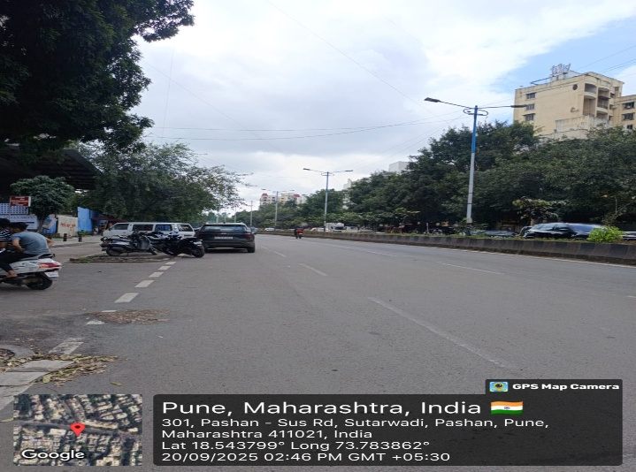
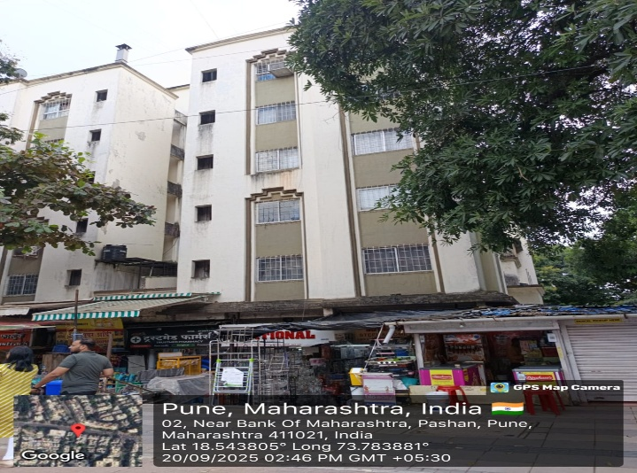
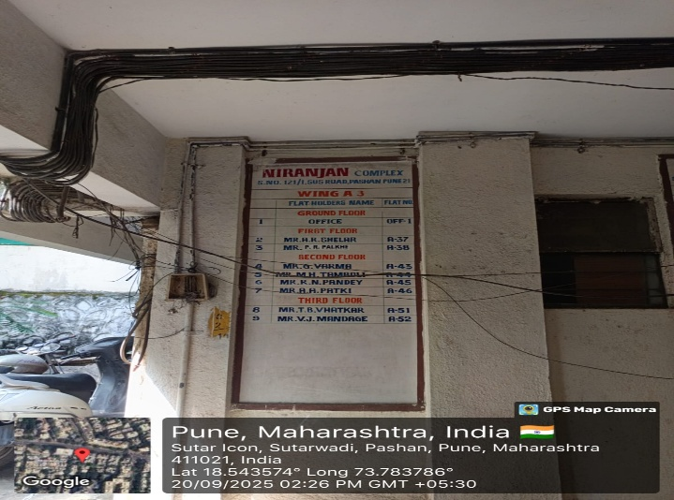
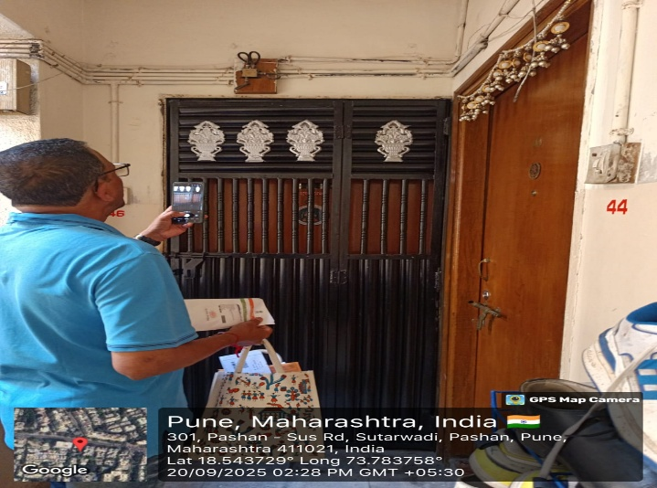
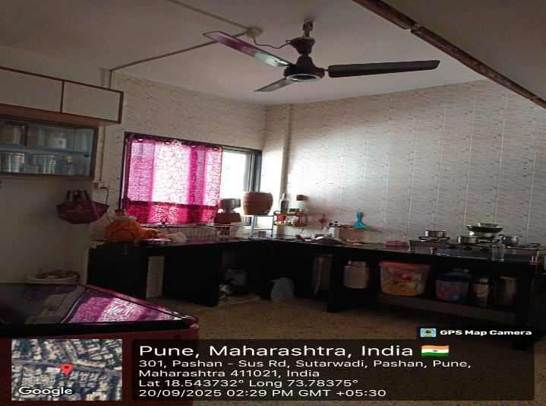
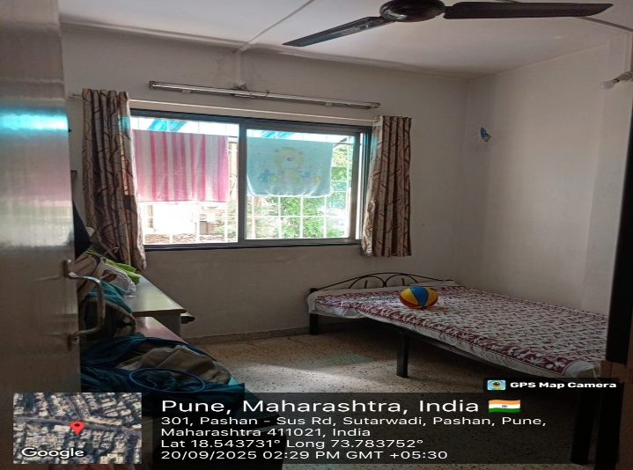

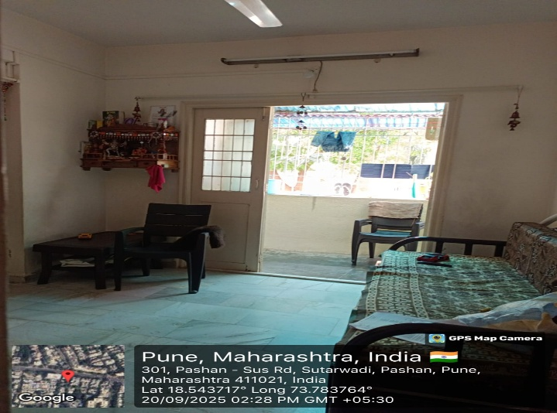
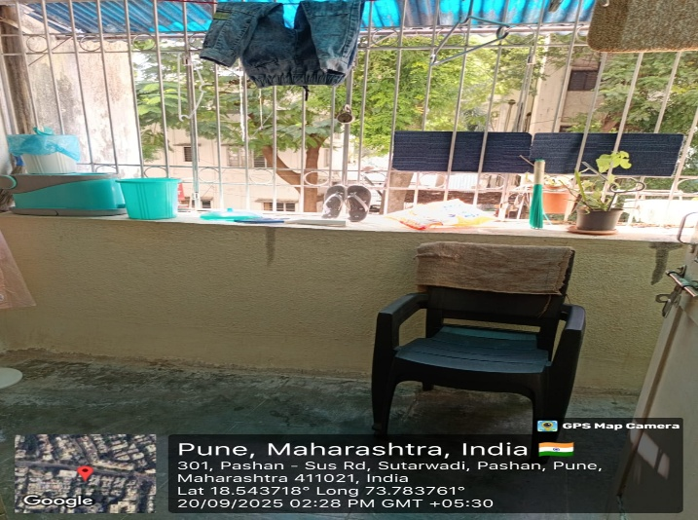
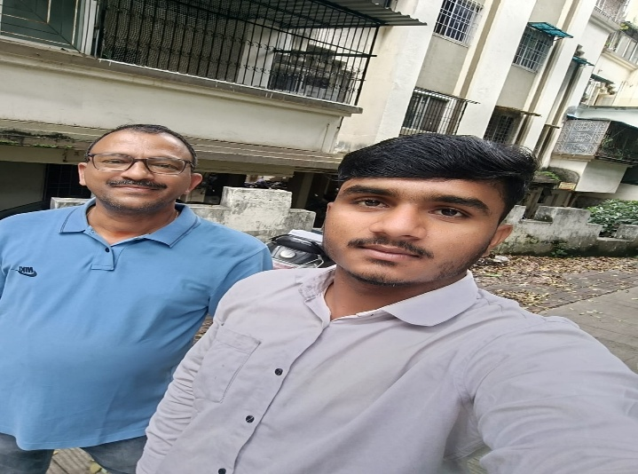
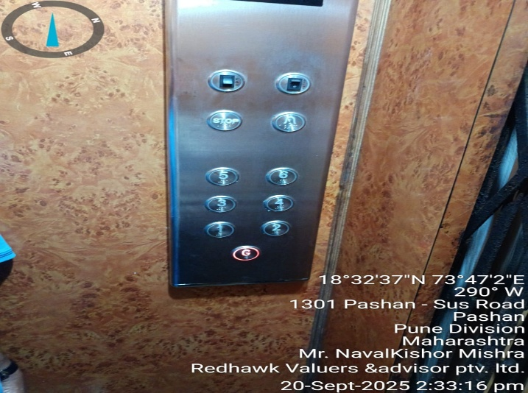
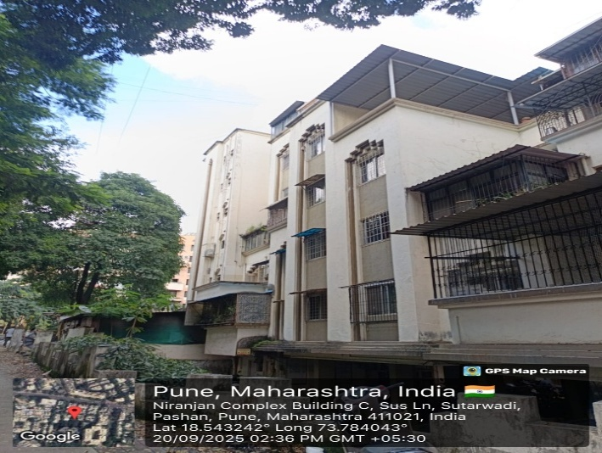

Google Location Map
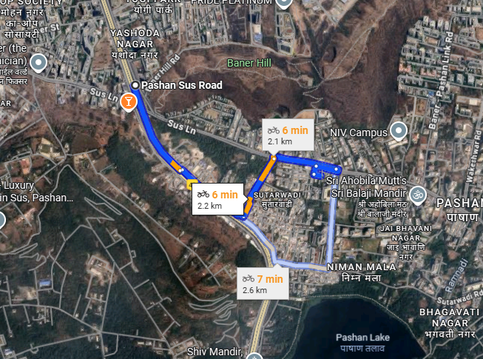
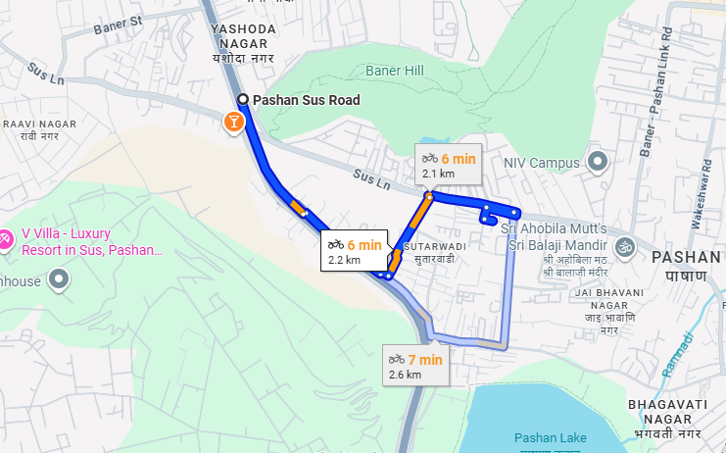

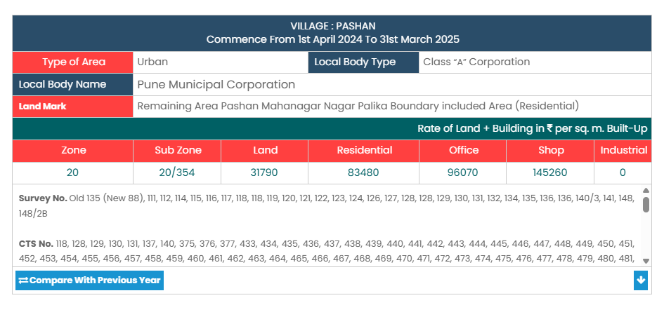

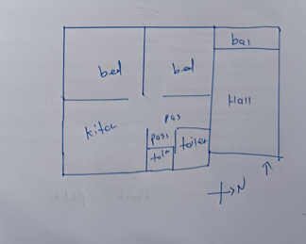

Documents:
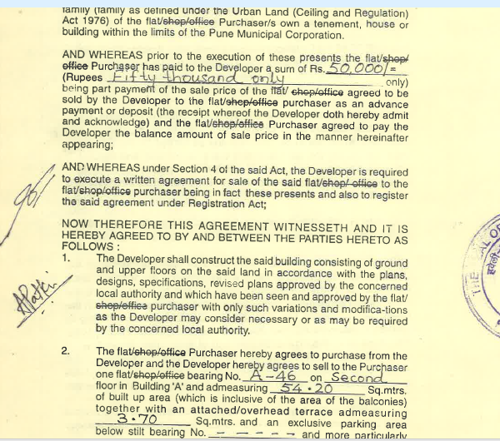
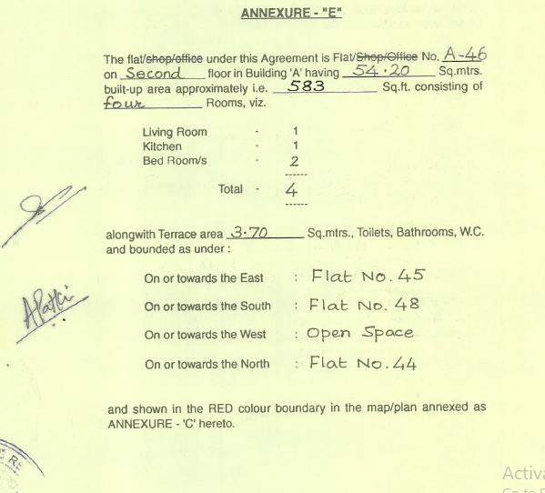
Market References:

